Robot Vision
A combination of hardware (cameras/sensors) and software (algorithms) which enable robots to “see”
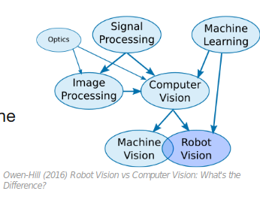
The richest source of information about the robot’s environment.
(Inter-)active perception allows robots to differentiate between different nouns in the real world.

Estimation of the weight of a sphere where the robot can:
change a viewpoint (left), observe actions (centre), interact with the scene (right).

Bohg et al. (2017) Interactive Perception: Leveraging Action in Perception and Perception in Action IEEE Trans. on Robotics.

Reference Material:
- Rafael C. Gonzalez, Digital Image Processing, classic textbook
- Official OpenCV tutorial: OpenCV-Python Tutorials
Today
- Part I - Images
- Part II - Image Geometry
- Part III - Point Clouds

Images

A set of pixels arranged into a 2D matrix (matrices)
Each pixel corresponds to light intensity
Discretised intensity levels (e.g. 8b, 16b)
Mono-chrome, colour and multi-spectral sensors
A source of information for image processing and computer vision

Open CV
• Open Source Computer Vision Library: Intel 1999
• +2500 optimized CV&ML algorithms - “gold standard” including
deep architectures
• C++ with multi-language bindings (Python, Java and MATLAB),
supports ROS
• multi-os, parallel hardware
• commercial, research and gov.; +47k users, 18m downloads
• applications: object/face/action recognition, camera/object/eye
tracking, 3D reconstruction, image stitching & indexing, etc.
• Intro to OpenCV with Python https://opencv-python-tutroals.readthedocs.io/en/latest/py_tutorials/py_tutorials.html

Open CV – Basic Operations

Getting Image Streams from a ROS topic

OpenCV and ROS play nicely
A dedicated CvBridge to help you getting and processing image from the robot

YOLO – You Only Look Once

• Project website: https://pjreddie.com/darknet/yolo/

• Original paper: https://pjreddie.com/media/files/papers/yolo_1.pdf

detectron2

Useful Vision Commands

